

A Project Report On

**Online Book Store Project**

**By**

**VIJAYARAJ V**

**Batch:** 2022 – 6518

**Center: Chennai**

Under the Guidance of,

**Chittaranjan Ghosh.**

**Technical Trainer**

**EduBridge**

(School of coding)

## Introduction:

Book’s Land is an Online Platform to order Books, Peoples can order the books what they want from their place, The books will be delivered to their places with in a days

. **Modules:-**

* Admin Module
* Customer Module
* Database Module

I have developed this Application in **Java, MySQL.** It’s a web-based project

The main objective of the Book’ Land is to reduce manual work and time. It is difficult to get the Books it took time and energy. To avoid this problem, I have planned to develop a web-based Online Book Store called Book’s Land. In Admin module, admin can add the Category and Products in the specific category. He can also remove the Products from the website. And category and product details also. Admin can only see the admin page and cart if he wants to order something.

* It manages the details of Books, Stocks, Price and all.
* Saves the time and energy of customers.
* This system makes customers information more secure.

Admin Module: Admin can able to Manage the Database of the site and perform given task or option in a given way.

Customer Module: Customer can add their details like username, password and Personal Details by clicking Sign up Button, They can also Edit or Modify their username, password and all by Simply Go to Profile Setting,

They can see the books and order the book by giving Book Code and Quantity , they can check status of the order

Database Module: Database Module contains the database address, username, password. It acts like the bridge between database and java

**Software Requirements:**

**Language:** Java, SQL .

**IDE’S :** Eclipse, MySQL workbench 8.0 CE.

**API’S :** JDBC

# Data Dictionary:

**Admin Table:**

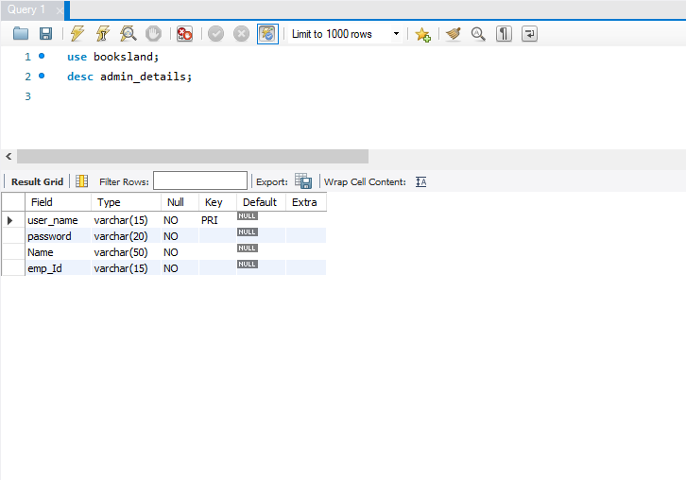

**Customer Table:**

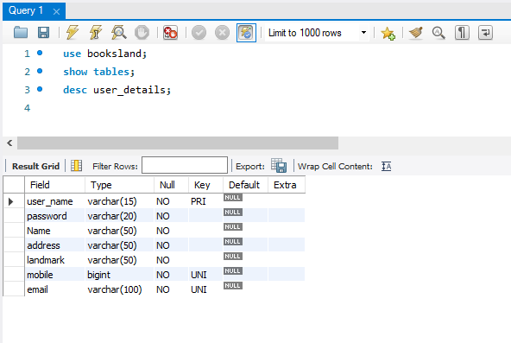

**Books Table:**

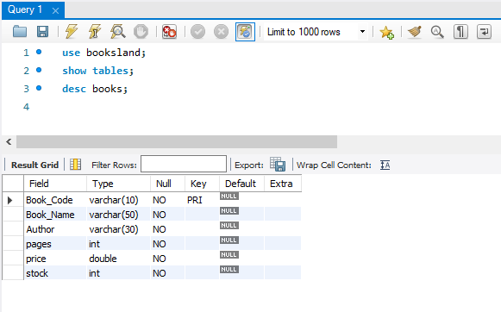

**Order Details:**

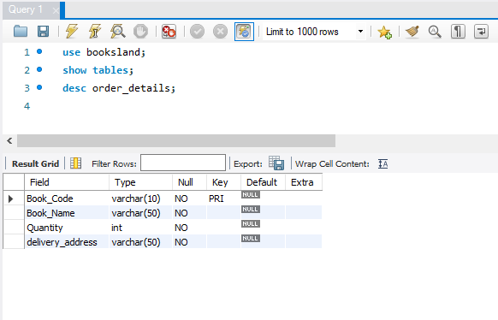

**Console Outputs:**

**Employee Page**

1. **Admin Login Page:**

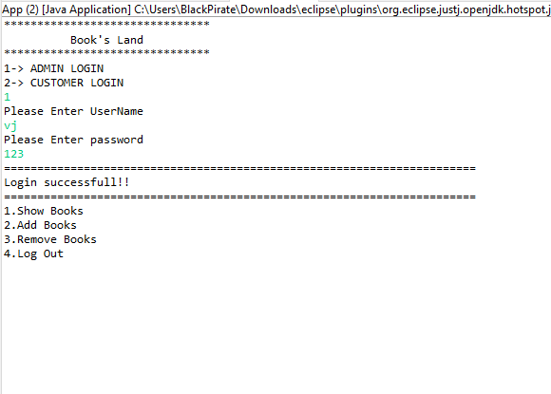

1. **Add Books:**

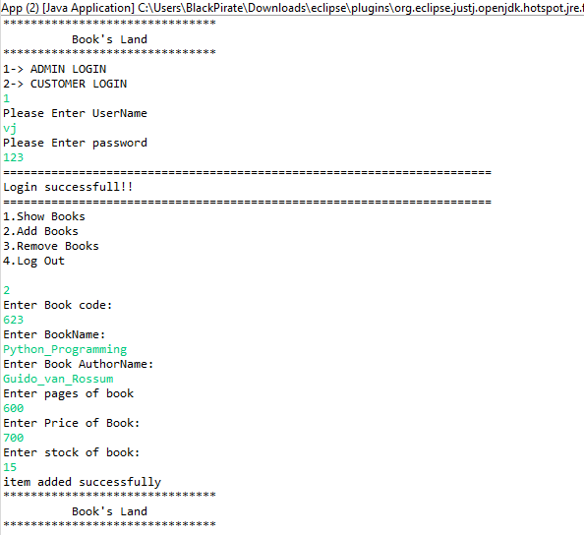

1. **Remove Book:**

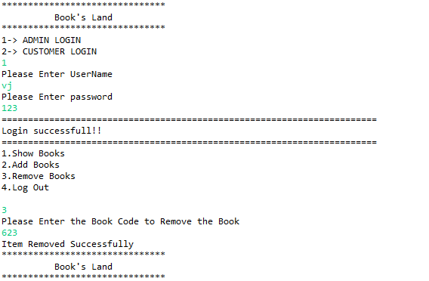

1. **Logout:**

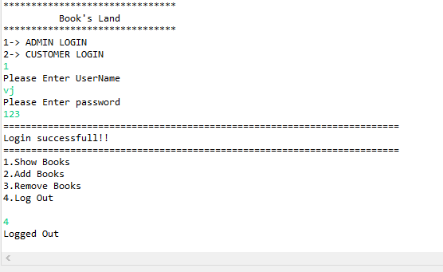

**Customer Page:**

1. **Sign up page:**

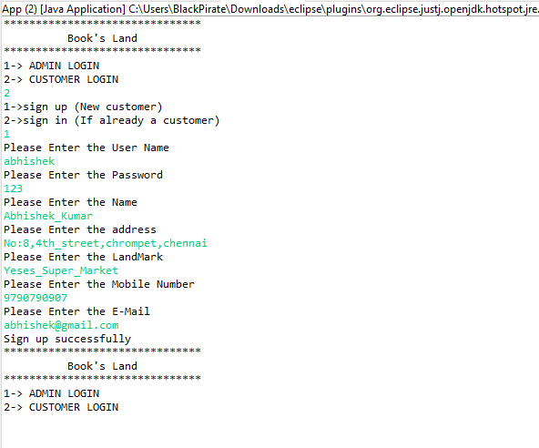

**2.Sign in Page:**

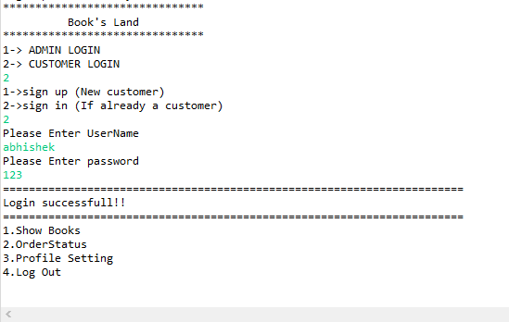

**3.Show Books page:**

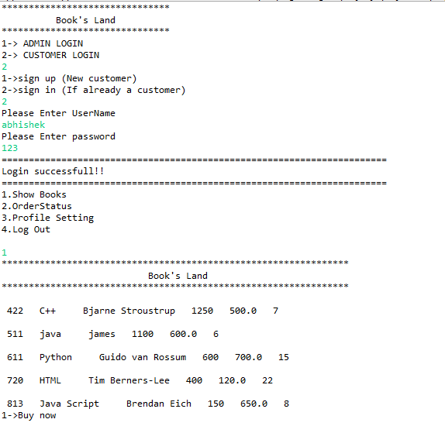

**4.Buy page:**

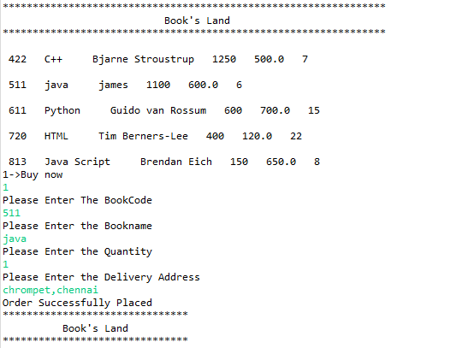

1. **Order Status:**

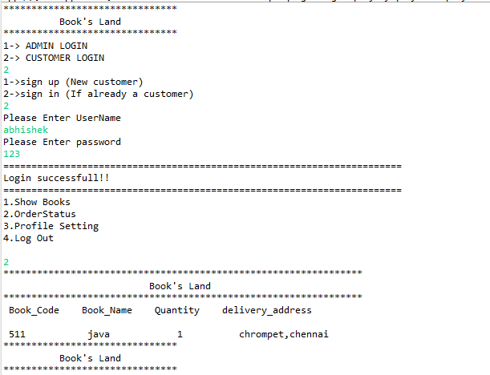

1. **Cancel the Order page:**

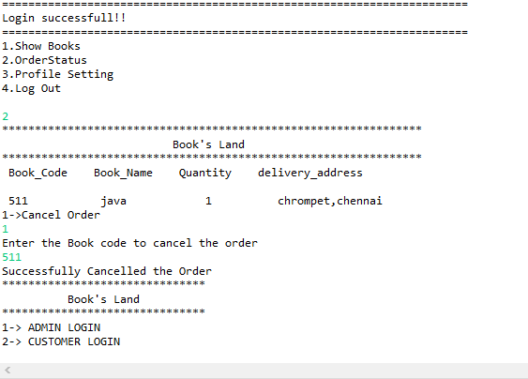

1. **Profile Setting:**

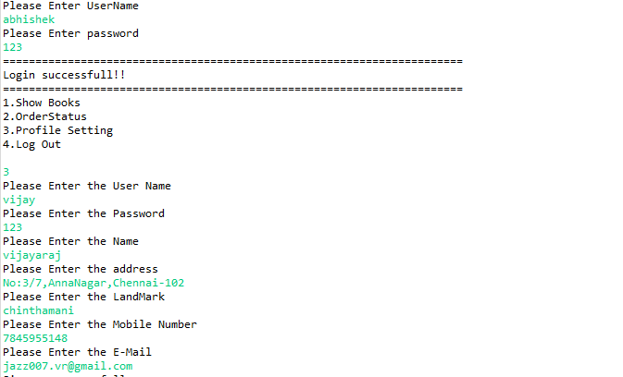

1. **Logout Customer:**

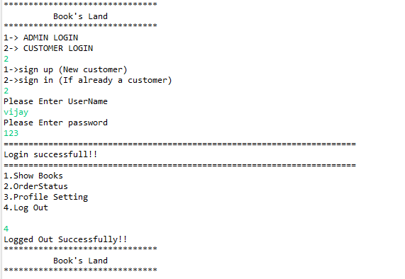

**Conclusion:**

The Online Book Store (Book’s Land) Summary as Details above the presentation of Fulfilled our app

To save the time and reliability of usage by customer who have love to read book. They

Can use the app to order in simple to purchase book

**Thank you...**